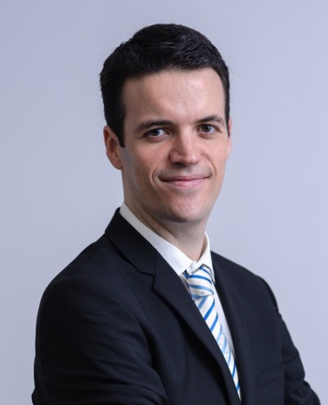
Alexandre Bussutil, MBA, is the founder and CEO of B-SCALED, a consulting company that helps tech startups to grow. He is also a startup mentor and visiting professor at IE Business School where he lectures on blockchain technologies. His non-profit activities include being a founding member of the European Decentralised Economy Council and a co-author of the book “Comunidad Blockchain” with blockchain España.
Prior to these activities, Alexandre held positions in technology and project management in energy management companies.

